**PROTECTION DEVICES**

- Protection devices for electrical circuits accomplish two main functions namely consistency as well as protection. Protection is assured through detaching power supply in a circuit through overcurrent protection, which removes fire hazards and electrocution. Additionally, the accurate protection may be required to obey with organization principles for some products. Designers must take time to know the different protection devices for circuits. Protection devices used to protect circuits from extreme voltages or currents.

- The circuit protection device is an electrical device used for preventing an unnecessary amount of current otherwise a short circuit. To ensure the highest security, there are many protection devices available in the market which offers you a total range of protection devices for circuits such as a fuse, circuit breakers, RCCB, gas discharge tubes, thyristors, and more.

**1. Miniature Circuit Breaker (MCB)**

* A Miniature Circuit Breaker (MCB) is an Electrical Switch which automatically switches off the electrical circuit during an abnormal condition of the network means in overload condition as well as faulty condition.
* Nowadays we use an MCB in a low voltage electrical network instead of a fuse. The fuse may not sense it but the miniature circuit breaker does it in a more reliable way. MCB is much more sensitive to overcurrent than a fuse.
* List of products: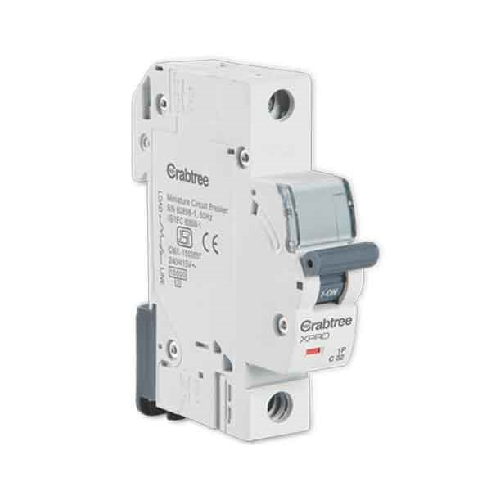

**No.1:** Crabtree 6A C-Curve 10kA 1 Pole MCB

Price: Rs. 150 (~~Rs. 205~~)

This 6A SP C-Curve 10kA MCB is a single pole highly durable MCB with finger touch proof terminals conforming to IP20 degree of protection. It is used in Single Phase Supply to break the phase only. It is ideal for the protection against overload and short circuit for Lighting & other Domestic Loads.

**PRODUCT SPECIFICATION**

|  |  |
| --- | --- |
| **Brand** | Crabtree |
| **Product Category** | Single Pole MCB |
| **Current Rating** | 6 A |
| **Triping Characteristics** | C-Curve |
| **Rated Short-Circuit Capacity** | 10kA |
| **Colour** | White |
| **Voltage** | 240 - 415 V AC |
| **Rated Operating Voltage Ue** | 440V |
| **Insulation Voltage** | 660 V |
| **Nominal Frequency** | 50 Hz |
| **Mounting Type** | On symmetric rail EN/IEC 60715 or DIN 35 rail |
| **Package Contents** | 1 SP MCB |
| **Certification** | IS/IEC 60898-1 |
| **Material** | Halogens-free plastic materials |
| **Warranty** | 2 Years (against manufacturing defects) |

**No.2:** Crabtree 10A C-Curve 10kA 1 Pole MCB

Price: Rs. 150 (~~Rs. 205~~)

This 10A SP C-Curve 10kA MCB is a single pole highly durable MCB with finger touch proof terminals conforming to IP20 degree of protection. It is used in Single Phase Supply to break the phase only. It is ideal for the protection against overload and short circuit for Lighting & other Domestic Loads.

**PRODUCT SPECIFICATION**

|  |  |
| --- | --- |
| **Brand** | Crabtree |
| **Product Category** | Single Pole MCB |
| **Current Rating** | 10 A |
| **Triping Characteristics** | C-Curve |
| **Rated Short-Circuit Capacity** | 10kA |
| **Colour** | White |
| **Voltage** | 240 - 415 V AC |
| **Rated Operating Voltage Ue** | 440V |
| **Insulation Voltage** | 660 V |
| **Nominal Frequency** | 50 Hz |
| **Mounting Type** | On symmetric rail EN/IEC 60715 or DIN 35 rail |
| **Package Contents** | 1 SP MCB |
| **Certification** | IS/IEC 60898-1 |
| **Material** | Halogens-free plastic materials |
| **Warranty** | 2 Years (against manufacturing defects) |

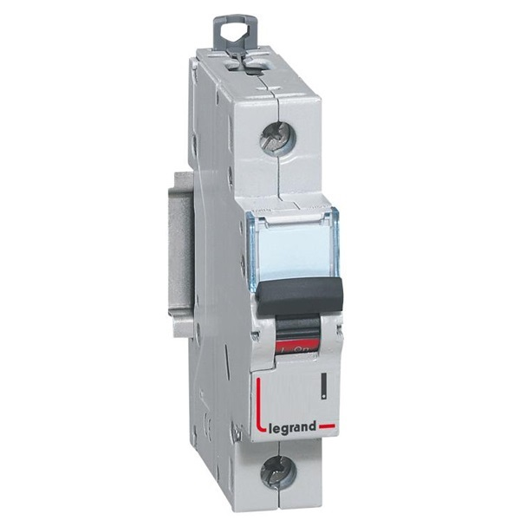**No.3:** Legrand DX3 408587 6A C-Curve 10kA 1 Pole MCB

Price: Rs. 177 (~~Rs. 322~~)

The DX3 MCB series are suitable both for commercial and residential installation.

This DX3 408587 6A SP C-Curve 10kA MCB is a single pole highly durable MCB with finger touch proof terminals conforming to IP20 degree of protection. It is used in Single Phase Supply to break the phase only. It is ideal for the protection against overload and short circuit for Lighting & other Domestic Loads.

**PRODUCT SPECIFICATION**

|  |  |
| --- | --- |
| **Brand** | Legrand |
| **Product Category** | Single Pole MCB |
| **Series** | Legrand DX3 |
| **Current Rating** | 6 A |
| **Triping Characteristics** | C-Curve |
| **Rated Short-Circuit Capacity** | 10kA |
| **Colour** | White |
| **Voltage** | 230 / 400 V AC |
| **Rated Operating Voltage Ue** | 440V |
| **Insulation Voltage** | 500 V |
| **Nominal Frequency** | 50/60 Hz |
| **Mounting Type** | On symmetric rail EN/IEC 60715 or DIN 35 rail. |
| **Package Contents** | 1 SP MCB |
| **Certification** | IEC 60947-2 |
| **Material** | Halogens-free plastic materials |
| **Warranty** | 2 Years (against manufacturing defects) |

**No.4:** Legrand DX3 408590 10A C-Curve 10kA 1 Pole MCB

Price: Rs. 177 (~~Rs. 322~~)

The DX3 MCB series are suitable both for commercial and residential installation.

This DX3 408590 10A SP C-Curve 10kA MCB is a single pole highly durable MCB with finger touch proof terminals conforming to IP20 degree of protection. It is used in Single Phase Supply to break the phase only. It is ideal for the protection against overload and short circuit for Lighting & other Domestic Loads.

**PRODUCT SPECIFICATION**

|  |  |
| --- | --- |
| **Brand** | Legrand |
| **Product Category** | Single Pole MCB |
| **Series** | Legrand DX3 |
| **Current Rating** | 10 A |
| **Triping Characteristics** | C-Curve |
| **Rated Short-Circuit Capacity** | 10kA |
| **Colour** | White |
| **Voltage** | 230 / 400 V AC |
| **Rated Operating Voltage Ue** | 440V |
| **Insulation Voltage** | 500 V |
| **Nominal Frequency** | 50/60 Hz |
| **Mounting Type** | On symmetric rail EN/IEC 60715 or DIN 35 rail. |
| **Package Contents** | 1 SP MCB |
| **Certification** | IEC 60947-2 |
| **Material** | Halogens-free plastic materials |
| **Warranty** | 2 Years (against manufacturing defects) |

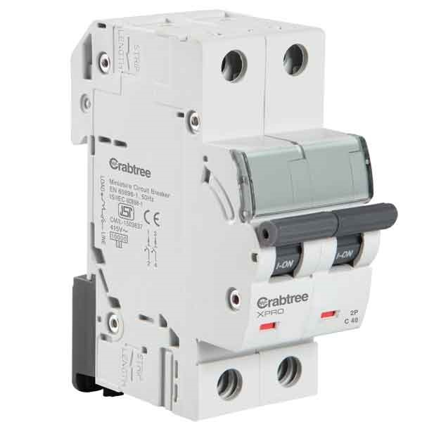**No.5:** Crabtree 6A C-Curve 10kA 2 Pole MCB

Price: Rs. 509 (~~Rs. 696~~)

This 6A DP C-Curve 10kA MCB is a two pole highly durable MCB with finger touch proof terminals conforming to IP20 degree of protection. It is used in Single Phase Supply to break the phase as well as neutral. It is ideal for the protection against overload and short circuit for Motor and other Inductive loads.

**PRODUCT SPECIFICATION**

|  |  |
| --- | --- |
| **Brand** | Crabtree |
| **Product Category** | Double Pole MCB |
| **Current Rating** | 6 A |
| **Triping Characteristics** | C-Curve |
| **Rated Short-Circuit Capacity** | 10kA |
| **Colour** | White |
| **Voltage** | 240 - 415 V AC |
| **Rated Operating Voltage Ue** | 440V |
| **Insulation Voltage** | 660 V |
| **Nominal Frequency** | 50 Hz |
| **Mounting Type** | On symmetric rail EN/IEC 60715 or DIN 35 rail. |
| **Package Contents** | 1 DP MCB |
| **Certification** | IS/IEC 60898-1 |
| **Material** | Halogens-free plastic materials |
| **Warranty** | 2 Years (against manufacturing defects) |

**No.6:** Crabtree 10A C-Curve 10kA 2 Pole MCB

Price: Rs. 509 (~~Rs. 696~~)

This 10A DP C-Curve 10kA MCB is a two pole highly durable MCB with finger touch proof terminals conforming to IP20 degree of protection. It is used in Single Phase Supply to break the phase as well as neutral. It is ideal for the protection against overload and short circuit for Motor and other Inductive loads.

**PRODUCT SPECIFICATION**

|  |  |
| --- | --- |
| **Brand** | Crabtree |
| **Product Category** | Double Pole MCB |
| **Current Rating** | 10 A |
| **Triping Characteristics** | C-Curve |
| **Rated Short-Circuit Capacity** | 10kA |
| **Colour** | White |
| **Voltage** | 240 - 415 V AC |
| **Rated Operating Voltage Ue** | 440V |
| **Insulation Voltage** | 660 V |
| **Nominal Frequency** | 50 Hz |
| **Mounting Type** | On symmetric rail EN/IEC 60715 or DIN 35 rail. |
| **Package Contents** | 1 DP MCB |
| **Certification** | IS/IEC 60898-1 |
| **Material** | Halogens-free plastic materials |
| **Warranty** | 2 Years (against manufacturing defects) |

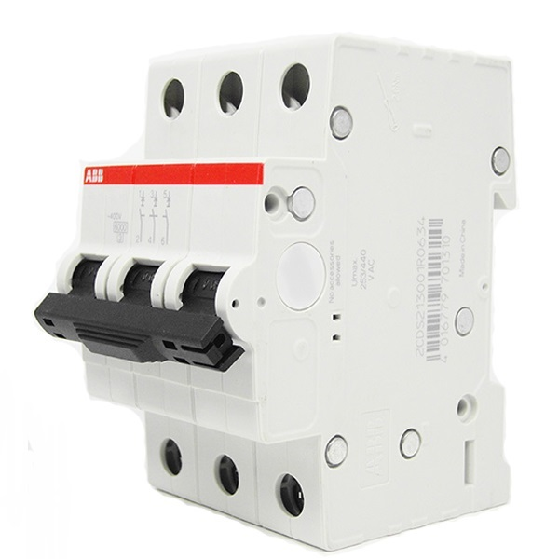**No.7:** ABB 6A C-Curve 10kA 3 Pole MCB

Price: Rs. 828 (~~Rs. 1380~~)

This 6A TP C-Curve 10kA MCB is a three pole highly durable MCB with finger touch proof terminals conforming to IP20 degree of protection. It is used in Three Phase Supply to break the phase and the neutral is not the part of the MCB. Moreover, it is ideal for the protection against overload and short circuit for Motor and other Inductive loads.

**PRODUCT SPECIFICATION**

|  |  |
| --- | --- |
| **Brand** | L&T |
| **Product Category** | Single Pole MCB |
| **Series** | L&T Exora |
| **Current Rating** | 6 A |
| **Triping Characteristics** | C-Curve |
| **Rated Short-Circuit Capacity** | 10kA |
| **Colour** | White |
| **Voltage** | 240 / 415V AC |
| **Rated Operating Voltage Ue** | 440V |
| **Insulation Voltage** | 500 V |
| **Nominal Frequency** | 50/60 Hz |
| **Mounting Type** | On symmetric rail EN/IEC 60715 or DIN 35 rail. |
| **Package Contents** | 1 SP MCB |
| **Certification** | IEC 60947-2 |
| **Material** | Halogens-free plastic materials |
| **Warranty** | 2 Years (against manufacturing defects) |

**No.8:** ABB 10A C-Curve 10kA 3 Pole MCB

Price: Rs. 828 (~~Rs. 1380~~)

This 10A SP C-Curve 10kA MCB is a single pole highly durable MCB with finger touch proof terminals conforming to IP20 degree of protection. It is used in Single Phase Supply to break the phase only. Moreover, it is ideal for the protection against overload and short circuit for Lighting & other Domestic Loads.

**PRODUCT SPECIFICATION**

|  |  |
| --- | --- |
| **Brand** | L&T |
| **Product Category** | Single Pole MCB |
| **Series** | L&T Exora |
| **Current Rating** | 10 A |
| **Triping Characteristics** | C-Curve |
| **Rated Short-Circuit Capacity** | 10kA |
| **Colour** | White |
| **Voltage** | 240 / 415V AC |
| **Rated Operating Voltage Ue** | 440V |
| **Insulation Voltage** | 500 V |
| **Nominal Frequency** | 50/60 Hz |
| **Mounting Type** | On symmetric rail EN/IEC 60715 or DIN 35 rail. |
| **Package Contents** | 1 SP MCB |
| **Certification** | IEC 60947-2 |
| **Material** | Halogens-free plastic materials |
| **Warranty** | 2 Years (against manufacturing defects) |

**2. Residual Current Circuit Breaker (RCCB)**

* The RCCB (Residual Current Circuit Breaker) or RCD (Residual Current Device) is a safety device which notices a problem in your home power supply then turns OFF in 10-15 milliseconds to stop electric shock. A residual current device does not give safety against short circuit or overload in the circuit, so we cannot change a fuse instead of RCCB.
* RCCBs are frequently incorporated with some type of circuit breaker like an MCB (miniature circuit breaker) or a fuse, which guards against overload current in the circuit. The residual current device also cannot notice a human being due to by mistake touching both conductors at a time.
* List of products:

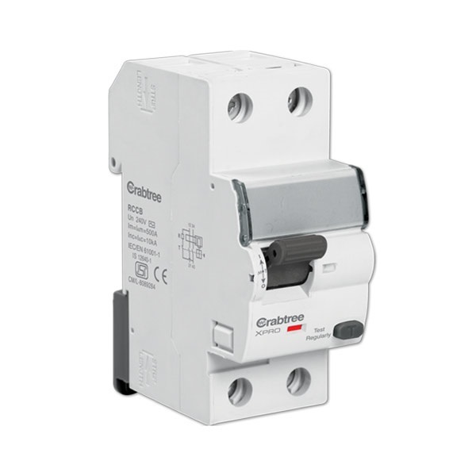**No.1:** Crabtree Xpro 16A 100mA 2 Pole RCCB

Price: Rs. 2005 (~~Rs. 2740~~)

Crabtree Xpro 16A 100mA Double Pole RCCB is capable to sense and compare the difference between the live and neutral voltages and then breaks the circuit when there is any imbalance. Consequently, it provides complete electrical protection together with MCB to both humans as well as equipments. This 100mA Double Pole RCCB has clearly visible ON and OFF positions with red and green colour respectively. It is ideal to use in in case of a single-phase supply that involves only a live and neutral wire. This product is ISI marked as per IS 12640-1 & IEC 61008 - 1 :1996

**PRODUCT SPECIFICATION**

|  |  |
| --- | --- |
| **Brand** | Crabtree Xpro |
| **Product Category** | Double Pole RCCB |
| **Current Rating** | 16 A |
| **Rated Sensitivity** | 100 mA |
| **Colour** | White |
| **Voltage** | 12 V AC |
| **Rated Operating Voltage Ue** | 240 V~ |
| **Nominal Frequency** | 50 Hz |
| **Short Circuit Withstand Capacity** | 10 kA |
| **Mounting Type** | On symmetric rail EN/IEC 60715 or DIN 35 rail. |
| **Package Contents** | 1 DP RCCB |
| **Certification** | IS 12640-1 & IEC/EN 61008-1 |
| **Material** | Halogens-free plastic materials |
| **Warranty** | 2 Years (against manufacturing defects) |

**No.2:** Crabtree Xpro 25A 100mA 2 Pole RCCB

Price: Rs. 2005 (~~Rs. 2740~~)

Crabtree Xpro 25A 100mA Double Pole RCCB is capable to sense and compare the difference between the live and neutral voltages and then breaks the circuit when there is any imbalance. Consequently, it provides complete electrical protection together with MCB to both humans as well as equipments. This 100mA Double Pole RCCB has clearly visible ON and OFF positions with red and green colour respectively. It is ideal to use in in case of a single-phase supply that involves only a live and neutral wire. This product is ISI marked as per IS 12640-1 & IEC 61008 - 1 :1996

**PRODUCT SPECIFICATION**

|  |  |
| --- | --- |
| **Brand** | Crabtree Xpro |
| **Product Category** | Double Pole RCCB |
| **Current Rating** | 25 A |
| **Rated Sensitivity** | 100 mA |
| **Colour** | White |
| **Voltage** | 12 V AC |
| **Rated Operating Voltage Ue** | 240 V~ |
| **Nominal Frequency** | 50 Hz |
| **Short Circuit Withstand Capacity** | 10 kA |
| **Mounting Type** | On symmetric rail EN/IEC 60715 or DIN 35 rail. |
| **Package Contents** | 1 DP RCCB |
| **Certification** | IS 12640-1 & IEC/EN 61008-1 |
| **Material** | Halogens-free plastic materials |
| **Warranty** | 2 Years (against manufacturing defects) |

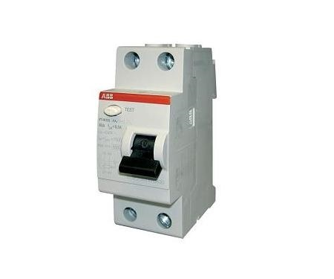**No.3:** ABB 25A 30mA 2 Pole RCCB

Price: Rs. 1857 (~~Rs. 3095~~)

ABB 25A 30mA Double Pole RCCB is capable to sense and compare the difference between the live and neutral voltages and then breaks the circuit when there is any imbalance. Consequently, it provides complete electrical protection together with MCB to both humans as well as equipments. This 30mA Double Pole RCCB has clearly visible ON and OFF positions with red and green colour respectively. It is ideal to use in case of a single-phase supply that involves only a live and neutral wire. This product is ISI marked as per IS 12640-1 & IEC 61008 - 1 :1996

**PRODUCT SPECIFICATION**

|  |  |
| --- | --- |
| **Brand** | ABB |
| **Product Category** | Double Pole RCCB |
| **Current Rating** | 25 A |
| **Rated Sensitivity** | 30 mA |
| **Colour** | White |
| **Voltage** | 12 V AC |
| **Rated Operating Voltage Ue** | 230 V~ |
| **Insulation Voltage** | 250 V |
| **Nominal Frequency** | 50/60 Hz |
| **Rated Impulse Withstand Voltage Uimp (kV)** | 6 kV |
| **Mounting Type** | On symmetric rail EN/IEC 60715 or DIN 35 rail. |
| **Package Contents** | 1 DP RCCB |
| **Certification** | IEC 61008 - 1 |
| **Material** | Halogens-free plastic materials |
| **Warranty** | 2 Years (against manufacturing defects) |

**No.4:** ABB 25A 100mA 2 Pole RCCB

Price: Rs. 1950 (~~Rs. 3250~~)

ABB 25A 100mA Double Pole RCCB is capable to sense and compare the difference between the live and neutral voltages and then breaks the circuit when there is any imbalance. Consequently, it provides complete electrical protection together with MCB to both humans as well as equipments. This 100mA Double Pole RCCB has clearly visible ON and OFF positions with red and green colour respectively. It is ideal to use in case of a single-phase supply that involves only a live and neutral wire. This product is ISI marked as per IS 12640-1 & IEC 61008 - 1 :1996

**PRODUCT SPECIFICATION**

|  |  |
| --- | --- |
| **Brand** | ABB |
| **Product Category** | Double Pole RCCB |
| **Current Rating** | 25 A |
| **Rated Sensitivity** | 100 mA |
| **Colour** | White |
| **Voltage** | 12 V AC |
| **Rated Operating Voltage Ue** | 230 V~ |
| **Insulation Voltage** | 250 V |
| **Nominal Frequency** | 50/60 Hz |
| **Rated Impulse Withstand Voltage Uimp (kV)** | 6 kV |
| **Mounting Type** | On symmetric rail EN/IEC 60715 or DIN 35 rail. |
| **Package Contents** | 1 DP RCCB |
| **Certification** | IEC 61008 - 1 |
| **Material** | Halogens-free plastic materials |
| **Warranty** | 2 Years (against manufacturing defects) |

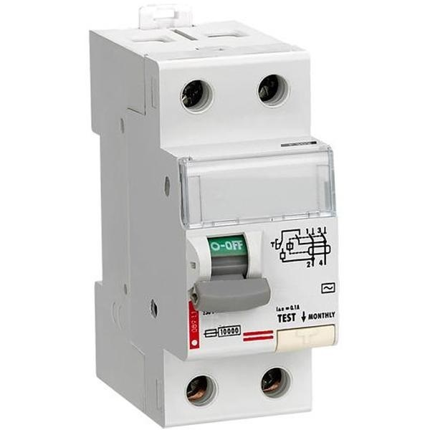**No.5:** Legrand DX3 411851 25A 30mA 2 Pole RCCB

Price: Rs. 2101 (~~Rs. 3502~~)

Legrand DX3 411851 25A 30mA DP RCCB is capable to sense and compare the difference between the live and neutral voltages and then breaks the circuit when there is any imbalance. Consequently, it provides complete electrical protection together with MCB to both humans as well as equipments. This 30mA Double Pole RCCB has clearly visible ON and OFF positions with red and green colour respectively. It is ideal to use in in case of a single-phase supply that involves only a live and neutral wire. This product is ISI marked as per IS 12640-1

**PRODUCT SPECIFICATION**

|  |  |
| --- | --- |
| **Brand** | Legrand |
| **Product Category** | Double Pole RCCB |
| **Current Rating** | 25 A |
| **Rated Sensitivity** | 30 mA |
| **Colour** | White |
| **Voltage** | 12 V AC |
| **Rated Operating Voltage Ue** | 230 V~ |
| **Insulation Voltage** | 250 V |
| **Nominal Frequency** | 50/60 Hz |
| **Rated Impulse Withstand Voltage Uimp (kV)** | 6 kV |
| **Mounting Type** | On symmetric rail EN/IEC 60715 or DIN 35 rail. |
| **Package Contents** | 1 DP RCCB |
| **Certification** | IEC 61008 - 1 |
| **Material** | Halogens-free plastic materials |
| **Warranty** | 2 Years (against manufacturing defects) |

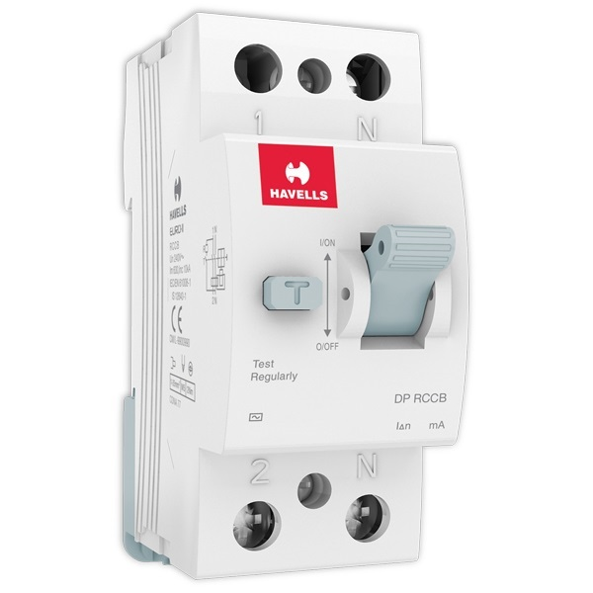**No.6:** Havells 25A 100mA 2 Pole RCCB

Price: Rs. 2206 (~~Rs. 2595~~)

Havells 25A 100mA Double Pole RCCB is capable to sense and compare the difference between the live and neutral voltages and then breaks the circuit when there is any imbalance. Consequently, it provides complete electrical protection together with MCB to both humans as well as equipments. This 100mA Double Pole RCCB has clearly visible ON and OFF positions with red and green colour respectively. It is ideal to use in in case of a single-phase supply that involves only a live and neutral wire. This product is ISI marked as per IS 12640-1 & IEC 61008 - 1 :1996

**PRODUCT SPECIFICATION**

|  |  |
| --- | --- |
| **Brand** | Havells |
| **Product Category** | Double Pole RCCB |
| **Current Rating** | 25 A |
| **Rated Sensitivity** | 100 mA |
| **Colour** | White |
| **Voltage** | 12 V AC |
| **Rated Operating Voltage Ue** | 230 V~ |
| **Insulation Voltage** | 250 V |
| **Nominal Frequency** | 50/60 Hz |
| **Rated Impulse Withstand Voltage Uimp (kV)** | 6 kV |
| **Mounting Type** | On symmetric rail EN/IEC 60715 or DIN 35 rail. |
| **Package Contents** | 1 DP RCCB |
| **Certification** | IS 12640-1 & IEC 61008-1 |
| **Material** | Halogens-free plastic materials |
| **Warranty** | 2 Years (against manufacturing defects) |

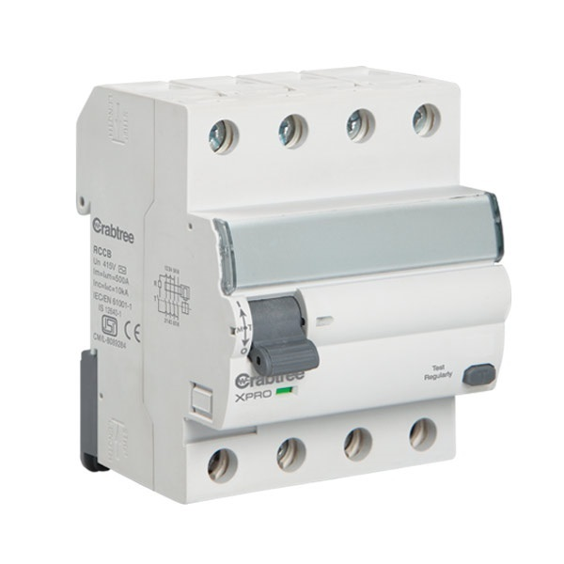**No.7:** Crabtree Xpro 40A 300mA 4 Pole RCCB

Price: Rs. 2490 (~~Rs. 3403~~)

Crabtree Xpro 40A 300mA Four Pole RCCB is capable to sense and compare the difference between the live and neutral voltages and then breaks the circuit when there is any imbalance. Consequently, it provides complete electrical protection together with MCB to both humans as well as equipments. This 300mA Four Pole RCCB has clearly visible ON and OFF positions with red and green colour respectively. It is ideal to use in case of a three-phase supply connection that involves only three phase wires and a neutral. This product is ISI marked as per IS 12640-1 & IEC 61008 - 1 :1996

**PRODUCT SPECIFICATION**

|  |  |
| --- | --- |
| **Brand** | Crabtree Xpro |
| **Product Category** | Four Pole RCCB |
| **Current Rating** | 40 A |
| **Rated Sensitivity** | 300 mA |
| **Colour** | White |
| **Voltage** | 12 V AC |
| **Rated Operating Voltage Ue** | 415V~ |
| **Nominal Frequency** | 50 Hz |
| **Short Circuit Withstand Capacity** | 10 kA |
| **Mounting Type** | On symmetric rail EN/IEC 60715 or DIN 35 rail. |
| **Package Contents** | 1 FP RCCB |
| **Certification** | IS 12640-1 & IEC/EN 61008-1 |
| **Material** | Halogens-free plastic materials |
| **Warranty** | 2 Years (against manufacturing defects) |

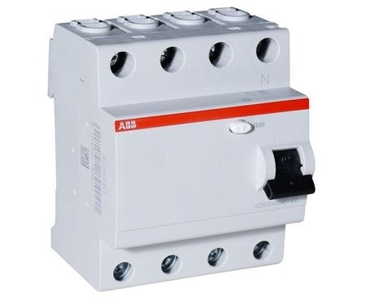**No.8:** ABB 25A 30mA 4 Pole RCCB

Price: Rs. 2466 (~~Rs. 4110~~)

ABB 25A 30mA Four Pole RCCB is capable to sense and compare the difference between the live and neutral voltages and then breaks the circuit when there is any imbalance. Consequently, it provides complete electrical protection together with MCB to both humans as well as equipments. This 30mA Four Pole RCCB has clearly visible ON and OFF positions with red and green colour respectively. It is ideal to use in case of a three-phase supply connection that involves only three phase wires and a neutral. This product is ISI marked as per IS 12640-1 & IEC 61008 - 1 :1996

**PRODUCT SPECIFICATION**

|  |  |
| --- | --- |
| **Brand** | ABB |
| **Product Category** | Four Pole RCCB |
| **Current Rating** | 25 A |
| **Rated Sensitivity** | 30 mA |
| **Colour** | White |
| **Voltage** | 12 V AC |
| **Rated Operating Voltage Ue** | 230/415V~ |
| **Insulation Voltage** | 500 V |
| **Nominal Frequency** | 50/60 Hz |
| **Rated Impulse Withstand Voltage Uimp (kV)** | 6 kV |
| **Mounting Type** | On symmetric rail EN/IEC 60715 or DIN 35 rail. |
| **Package Contents** | 1 FP RCCB |
| **Certification** | IEC 61008 - 1 |
| **Material** | Halogens-free plastic materials |
| **Warranty** | 2 Years (against manufacturing defects) |

**3. Residual Current Circuit Breaker With Overcurrent (RCBO)**

* The RCBO meaning is residual current circuit breaker with overcurrent protection. These devices are designed to ensure the safe operation of electrical circuits, triggering disconnection whenever an imbalance is detected. They are primarily used for the purpose of combined protection against overloading and short-circuiting against earth leakage currents.
* RCBOs help in sensing this kind of faults and trip the circuit ensuring complete protection of the people and connected equipment.
* List of products:

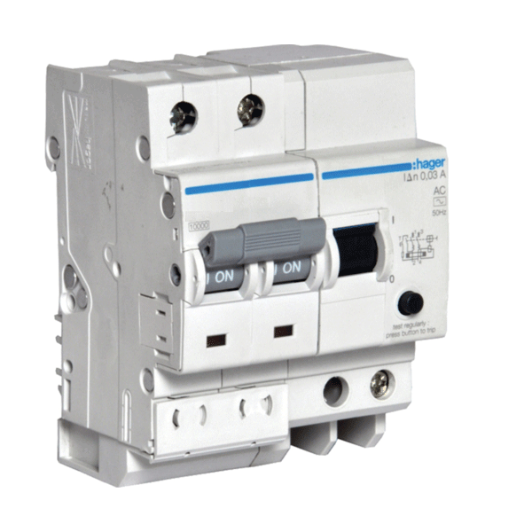**No.1:** Hager ADC216Y 16A 30mA Double Pole RCBO

Price: Rs. 2536 (~~Rs. 3825~~)

This 16A 30mA Double Pole RCBO from Hager is designed to ensure efficiency and protection against current overloads and earth leakage currents.

**PRODUCT SPECIFICATION**

|  |  |
| --- | --- |
| **Brand** | Hager |
| **Product Category** | Double Pole RCBOs |
| **Current Rating** | 16 A |
| **Rated Sensitivity** | 30 mA |
| **Colour** | White |
| **Voltage** | 12 V AC |
| **Rated Operating Voltage Ue** | 230 V~ |
| **Insulation Voltage** | 250 V |
| **Nominal Frequency** | 50/60 Hz |
| **Rated Impulse Withstand Voltage Uimp (kV)** | 6 kV |
| **Mounting Type** | On symmetric rail EN/IEC 60715 or DIN 35 rail. |
| **Package Contents** | 1 DP RCBO |
| **Certification** | IEC 61008 - 1 |
| **Material** | Halogens-free plastic materials |
| **Warranty** | 2 Years (against manufacturing defects) |

**No.2:** Hager ADC225Y 25A 30mA Double Pole RCBO

Price: Rs. 2536 (~~Rs. 3825~~)

This 25A 30mA Double Pole RCBO from Hager is designed to ensure efficiency and protection against current overloads and earth leakage currents.

**PRODUCT SPECIFICATION**

|  |  |
| --- | --- |
| **Brand** | Hager |
| **Product Category** | Double Pole RCBOs |
| **Current Rating** | 25 A |
| **Rated Sensitivity** | 30 mA |
| **Colour** | White |
| **Voltage** | 12 V AC |
| **Rated Operating Voltage Ue** | 230 V~ |
| **Insulation Voltage** | 250 V |
| **Nominal Frequency** | 50/60 Hz |
| **Rated Impulse Withstand Voltage Uimp (kV)** | 6 kV |
| **Mounting Type** | On symmetric rail EN/IEC 60715 or DIN 35 rail. |
| **Package Contents** | 1 DP RCBO |
| **Certification** | IEC 61008 - 1 |
| **Material** | Halogens-free plastic materials |
| **Warranty** | 2 Years (against manufacturing defects) |

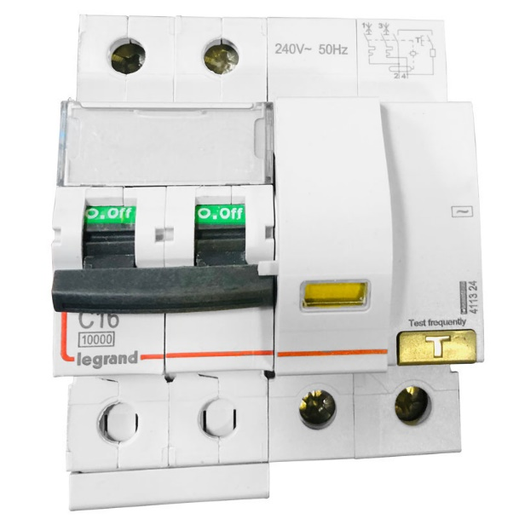**No.3:** Legrand DX3 411324 16A 30mA Double Pole RCBO

Price: Rs. 2446 (~~Rs. 4110~~)

This DX3 411324 16A 30mA Double Pole RCBO helps in sensing the faults like over currents and earth leakage current and trips the circuit, providing complete protection to both connected equipments and people. It is used in Single Phase Supply to break the phase as well as neutral.

**PRODUCT SPECIFICATION**

|  |  |
| --- | --- |
| **Brand** | Legrand |
| **Product Category** | Double Pole RCBOs |
| **Current Rating** | 16 A |
| **Rated Sensitivity** | 30 mA |
| **Colour** | White |
| **Voltage** | 12 V AC |
| **Rated Operating Voltage Ue** | 230 V~ |
| **Insulation Voltage** | 250 V |
| **Nominal Frequency** | 50/60 Hz |
| **Rated Impulse Withstand Voltage Uimp (kV)** | 6 kV |
| **Mounting Type** | On symmetric rail EN/IEC 60715 or DIN 35 rail. |
| **Package Contents** | 1 DP RCBO |
| **Certification** | IEC 61008 - 1 |
| **Material** | Halogens-free plastic materials |
| **Warranty** | 2 Years (against manufacturing defects) |

**No.4:** Legrand DX3 411325 25A 30mA Double Pole RCBO

Price: Rs. 2446 (~~Rs. 4110~~)

This DX3 411325 25A 30mA Double Pole RCBO helps in sensing the faults like over currents and earth leakage current and trips the circuit, providing complete protection to both connected equipments and people. It is used in Single Phase Supply to break the phase as well as neutral.

**PRODUCT SPECIFICATION**

|  |  |
| --- | --- |
| **Brand** | Legrand |
| **Product Category** | Double Pole RCBOs |
| **Current Rating** | 25 A |
| **Rated Sensitivity** | 30 mA |
| **Colour** | White |
| **Voltage** | 12 V AC |
| **Rated Operating Voltage Ue** | 230 V~ |
| **Insulation Voltage** | 250 V |
| **Nominal Frequency** | 50/60 Hz |
| **Rated Impulse Withstand Voltage Uimp (kV)** | 6 kV |
| **Mounting Type** | On symmetric rail EN/IEC 60715 or DIN 35 rail. |
| **Package Contents** | 1 DP RCBO |
| **Certification** | IEC 61008 - 1 |
| **Material** | Halogens-free plastic materials |
| **Warranty** | 2 Years (against manufacturing defects) |

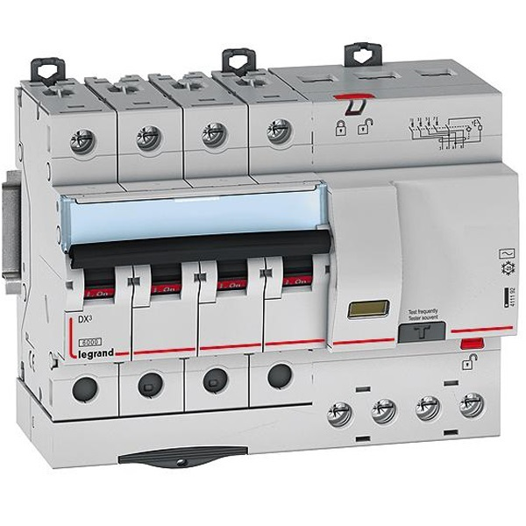**No.5:** Legrand DX3 411365 16A 30mA Four Pole RCBO

Price: Rs. 3476 (~~Rs. 5794~~)

This DX3 411365 16A 30mA Four Pole RCBO helps in sensing the faults like over currents and earth leakage current and trips the circuit, providing complete protection to both connected equipments and people. It is used in Three Phase Supply to break the phase and the neutral.

**PRODUCT SPECIFICATION**

|  |  |
| --- | --- |
| **Brand** | Legrand |
| **Product Category** | Four Pole RCBOs |
| **Current Rating** | 16 A |
| **Rated Sensitivity** | 30 mA |
| **Colour** | White |
| **Voltage** | 12 V AC |
| **Rated Operating Voltage Ue** | 230 V~ |
| **Insulation Voltage** | 250 V |
| **Nominal Frequency** | 50/60 Hz |
| **Rated Impulse Withstand Voltage Uimp (kV)** | 6 kV |
| **Mounting Type** | On symmetric rail EN/IEC 60715 or DIN 35 rail. |
| **Package Contents** | 1 FP RCBO |
| **Certification** | IEC 61008 - 1 |
| **Material** | Halogens-free plastic materials |
| **Warranty** | 2 Years (against manufacturing defects) |

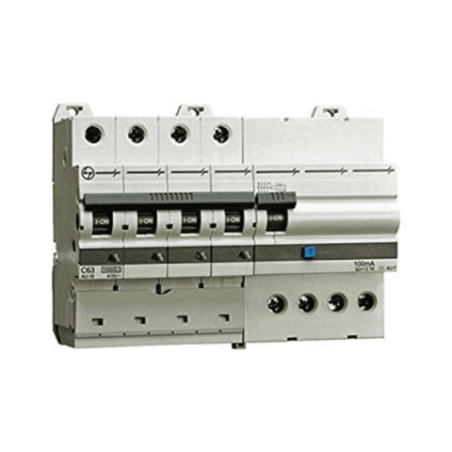**No.6:** L&T AUF3C401603 16A 30mA Four Pole RCBO

Price: Rs. 3900 (~~Rs. 4875~~)

This L&T AUF3C401603 16A 30mA Four Pole RCBO helps in sensing the faults like over currents and earth leakage current and trips the circuit, providing complete protection to both connected equipments and people. It is used in Three Phase Supply to break the phase and the neutral.

**PRODUCT SPECIFICATION**

|  |  |
| --- | --- |
| **Brand** | L&T |
| **Product Category** | Four Pole RCBOs |
| **Current Rating** | 16 A |
| **Rated Sensitivity** | 30 mA |
| **Mounting Type** | On symmetric rail EN/IEC 60715 or DIN 35 rail. |
| **Package Contents** | 1 FP RCBO |
| **Warranty** | 2 Years (against manufacturing defects) |

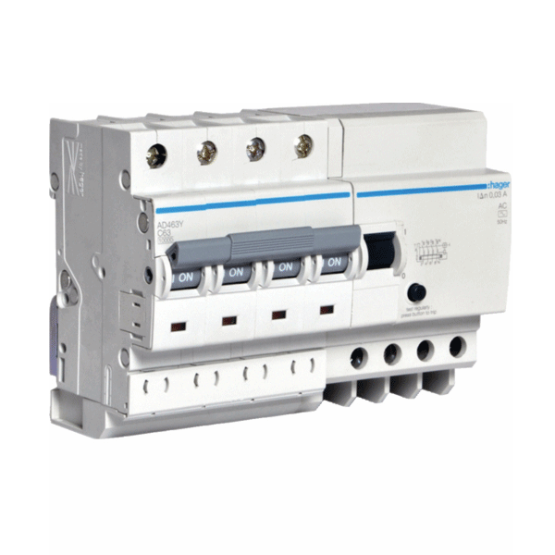**No.7:** Hager ADC416Y 16A 30mA Four Pole RCBO

Price: Rs. 3573 (~~Rs. 6260~~)

This 16A 30mA Four Pole RCBO from Hager is designed to ensure efficiency and protection against current overload and earth leakage currents.

**PRODUCT SPECIFICATION**

|  |  |
| --- | --- |
| **Brand** | Hager |
| **Product Category** | Four Pole RCBOs |
| **Current Rating** | 16 A |
| **Rated Sensitivity** | 30 mA |
| **Colour** | White |
| **Voltage** | 12 V AC |
| **Rated Operating Voltage Ue** | 230 V~ |
| **Insulation Voltage** | 250 V |
| **Nominal Frequency** | 50/60 Hz |
| **Rated Impulse Withstand Voltage Uimp (kV)** | 6 kV |
| **Mounting Type** | On symmetric rail EN/IEC 60715 or DIN 35 rail. |
| **Package Contents** | 1 FP RCBO |
| **Certification** | IEC 61008 - 1 |
| **Material** | Halogens-free plastic materials |
| **Warranty** | 2 Years (against manufacturing defects) |